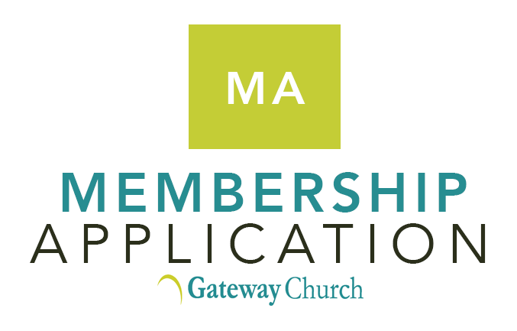

  - In response to God’s leading in my life, I would like to request membership in Gateway Church, a church of the Christian and Missionary Alliance in Canada.

  - I have experienced the new birth in Christ. I am trusting in God’s grace alone through faith in Christ alone for the forgiveness of my sins and my assurance of eternal life.

  - I understand that Gateway Church membership is a solemn covenant where I agree to engage in a lifestyle of spiritual growth and accountability with my brothers and sisters in Christ.

  - I have read and agree with Gateway’s Statement of Faith, Local Church Constitution and the Discipline and Restoration Policy.

  - I have attended the Intro to Gateway seminar.

  - I agree to attend worship regularly at Gateway and to use my spiritual gifts to build up the body of Christ.

  - I commit to financially support the local and global ministries of Gateway.

  - I make a solemn promise before God that I will not gossip about others in my Gateway church family.

  - I have made a public confession of my faith in Christ by baptism as a believer.

  - In applying to become a member of Gateway Church, I gladly renounce all known sin in my life, and solemnly affirm that I am trusting in Jesus to help me to resist temptation and experience freedom from the power of sin that He died to give to me. I hereby give my informed consent for the Gateway Board to lovingly confront me if my behaviour is in unrepentant violation of Scriptural moral standards.

  - I have read and will abide by Gateway’s Statement on Human Sexuality. I understand that members who are, without repentance, engaging in sexual behaviour and relationships contrary to the Statement on Human Sexuality (this includes, but is not limited to pre-marital relationships, extra-marital relationships, same-sex relationships, and polyamorous relationships) or persons who are not able to abide by Gateway’s Statement on Human Sexuality shall not be issued nor continue in membership at Gateway Church.

  - If I should come to the point where I no longer meet these qualifications for membership at Gateway Church, I will voluntarily remove myself from membership by informing the Board.

Name: _________________________________________________

Signed: ________________________________________________

Date: __________________________________________________

Gateway teaches and models the importance of Christ’s disciples being baptised as Christ commanded in the Great Commission (see Matthew 28:19,20). At the same time, Gateway does not see believers’ baptism as an issue that is essential for salvation (Ephesians 2:9,10 mentions that salvation is by grace alone through faith in Christ alone). Therefore, the Board of Gateway may decide, on a case by case basis, to extend membership to individuals who 1. were baptized as an infant but not as a believer, and 2. who have studied the issue biblically and have respectfully arrived at a different conclusion about the issue of infant or believers’ baptism, and 3. who present a credible and public testimony of faith in the Lord Jesus Christ and, 4. who meet all other qualifications for membership at Gateway.

